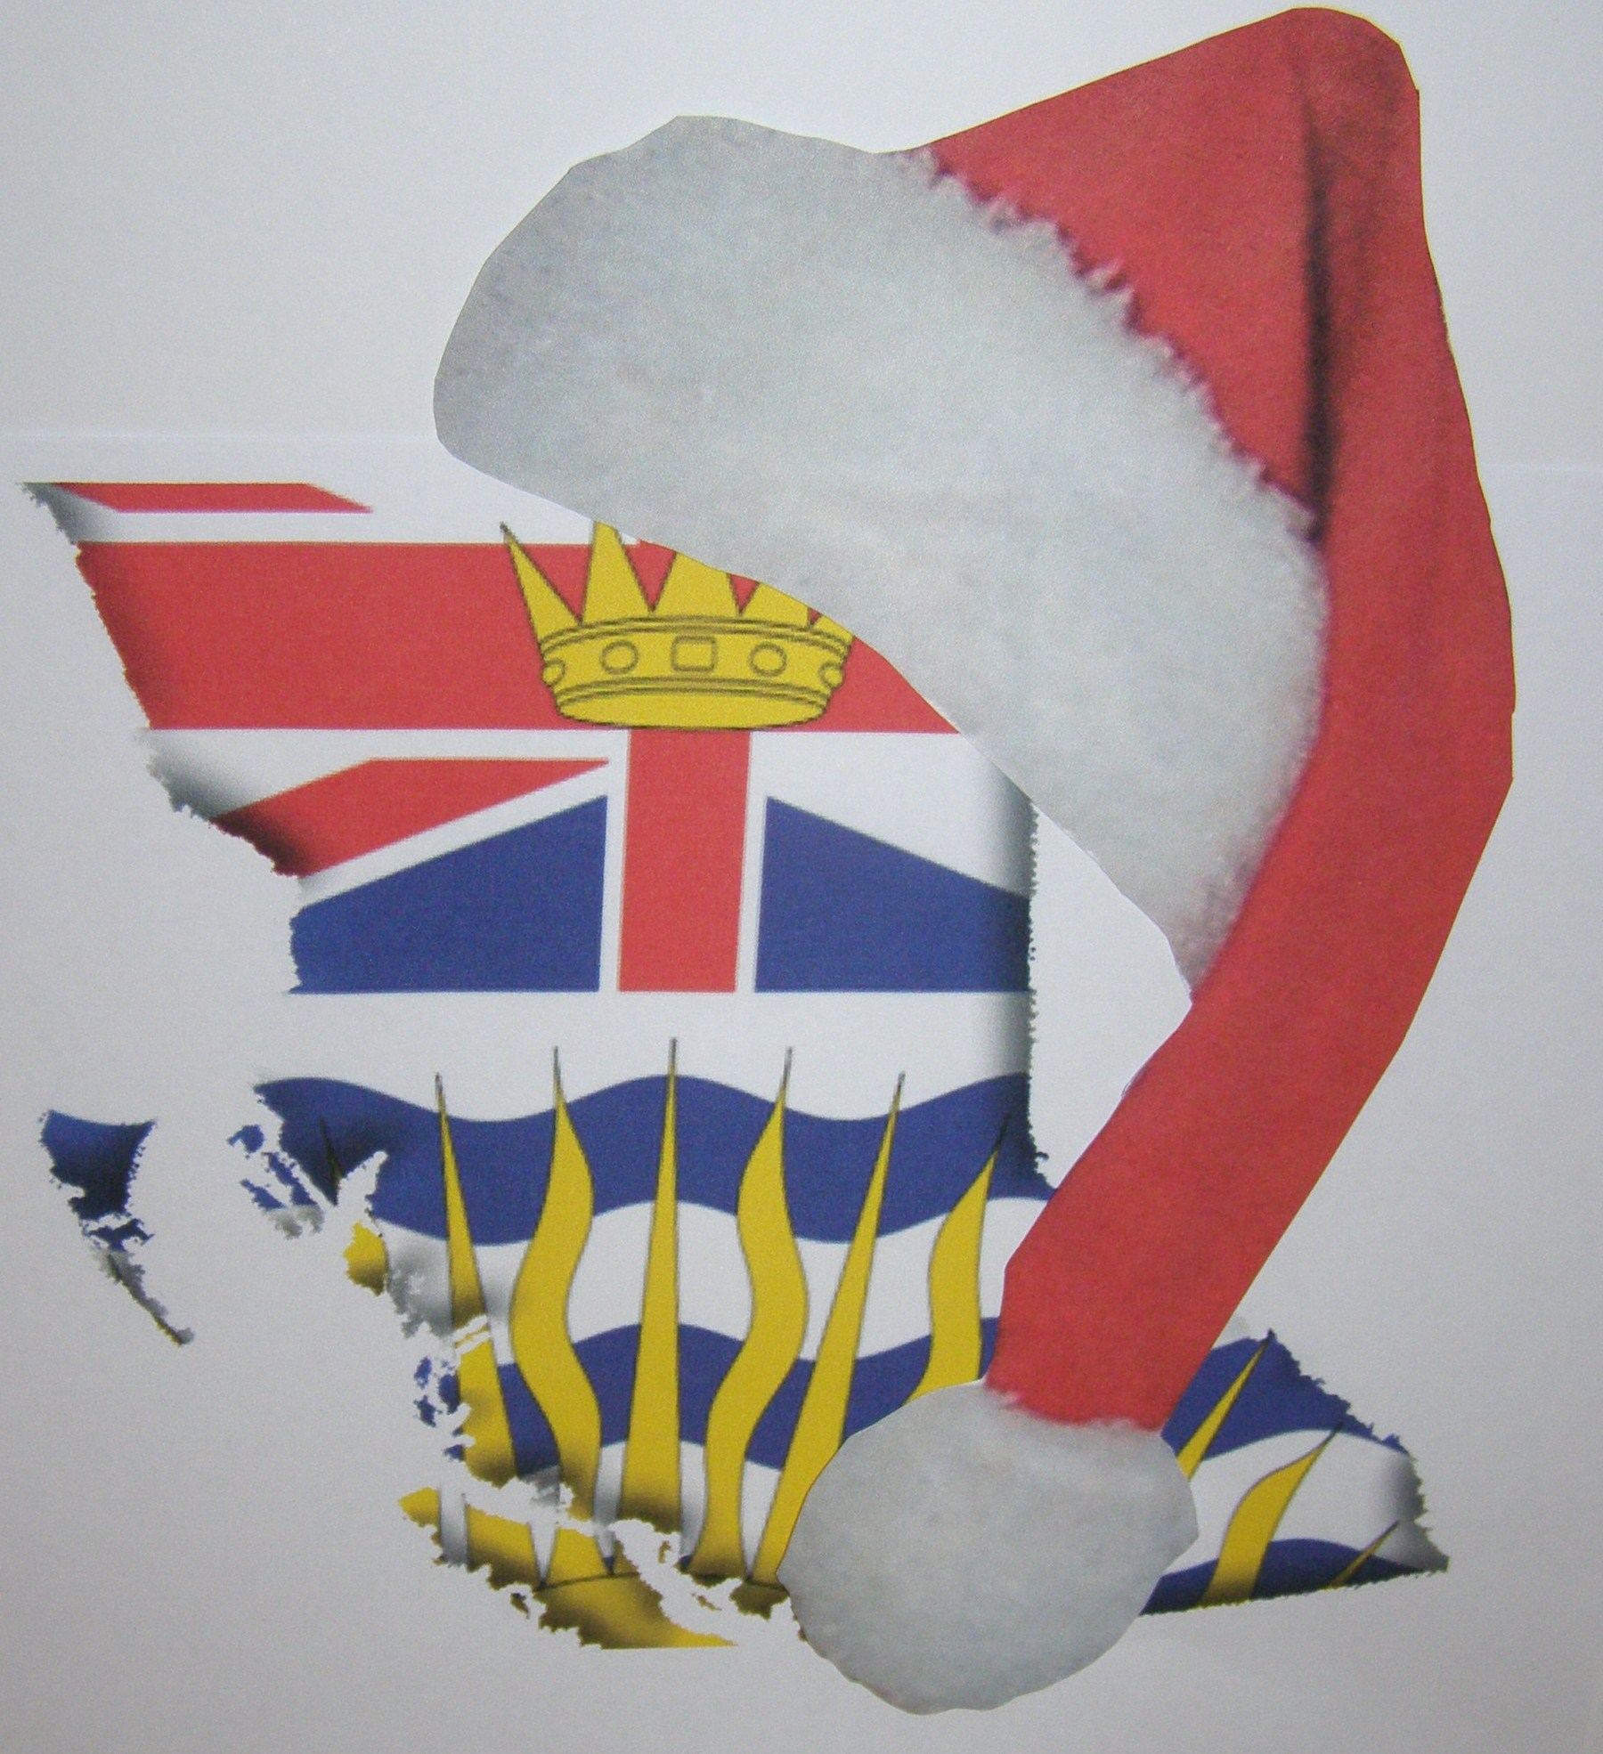
^{Made in BC Christmas Presents}
^{Christmas in Ladner}
Dates: Friday, December 2, 2011 5:00 p.m. to 9:00
& Saturday, December 3, 2011 9:00 am to 4:00 pm
Where:
Oddfellows Hall
5425 Ladner Trunk Road
Delta, BC
Name:
Business
Name:
Address: | _____________________________________________________________  City:______________________________________________________ |  |  |  | Web Site:  _______________________________________
Email
Address:
Phone: |  |  | Fax:
Product Description:
Table/Space Rental  - includes 6’x 2’ table & 2 chairs.  - Table/space sharing prohibited  - Product donation required for door prize draws  - Electricity available. Vendors must provide extension cords  - Mute coloured table covers required  - Venue preferences will be considered but not guaranteed. Vendors will be notified of venue |  | Payment must be enclosed with registration  (Note: A 2 Day Event)  - 1 space – table required $85.00  - 1 space – no table required $85.00  - 2 spaces – table required $125.00  - 2 spaces – no table required $125.00  - 3 spaces – tables required $195.00  - 3 spaces – no tables required $195.00  - Electricity required

IMPORTANT: Please submit photos of your merchandise with application and an application fee of $10. If you are not accepted, your rental cheque will be returned. Only products made in BC are acceptable (imported raw materials are acceptable, but priority will be given to applicants in each product category that have the greatest local content). If available please also provide photos of your display/exhibit from other markets that show your display skill and product presentation.
Photos may be submitted by email to madeinbcchristmas@gmail.com, but will only be considered when a registration application and fees is received.

Vendor Application

Registration Amount
Enclosed:

$__________________
(cheques payable to Donna Passmore)
13821 Blackburn Avenue
White Rock, V4B 2Z1

